Flower-Tower

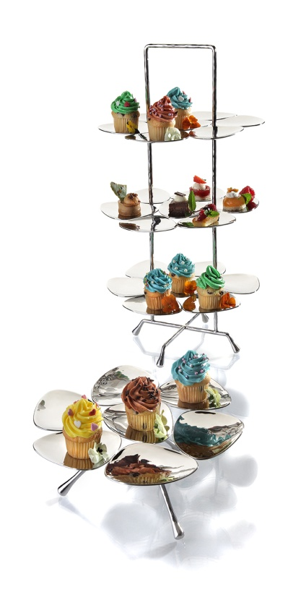
Organically shaped plates, seven of which combined to a platform, generate presentation levels of a floral character.

This play of shapes, combined with the gloss and reflections of hammered and polished stainless steel, creates the special appeal of this product line. The two etageres allow a visually harmonious but still flexible and diversified presentation of finger food, petit fours, elaborately decorated cup cakes and other small delights.

The big etagere offers space for up to 21 delicacies on three different levels. By means of the same design the small variant with one level forms a decorative complement to the three-tier version.
Even as stylish storage dish for different types of fruit, jewellery or accessories of daily use this product is ideally suitable.

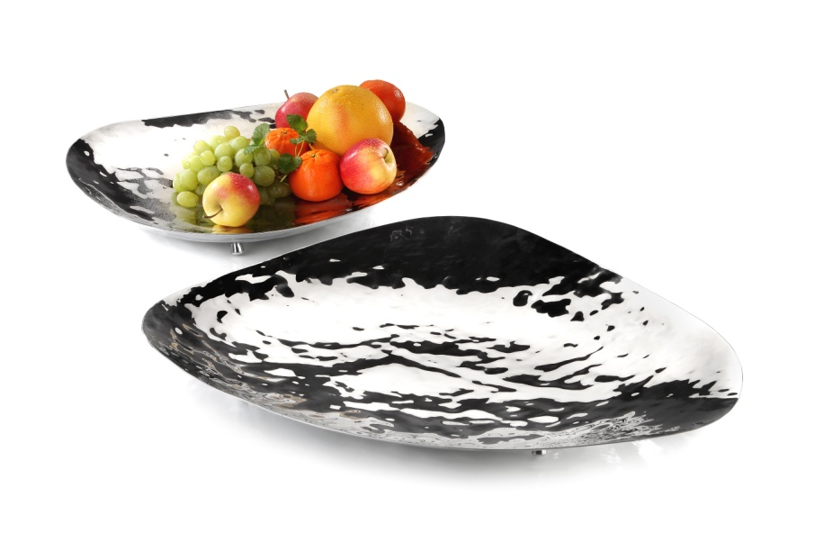
A nice complement is the 50 cm large fruit bowl. The organic shape of this artisan gem originates from the small platforms of the Flower-Power tier stands. Four unobstrusive feet provide a firm stand.

Even when unfilled this flat bowl convinces by the gently hammered structures and the specular surface of the polished stainless steel.

A highlight in every ambience, tasteful and decorative!

Design: Itamar Harari

More Information: WWW.ZIEHER.COM

More Information: WWW.ZIEHER-SELECTION.COM

