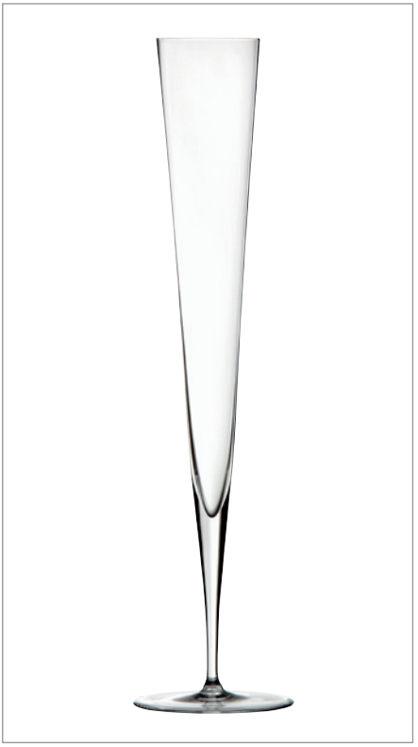
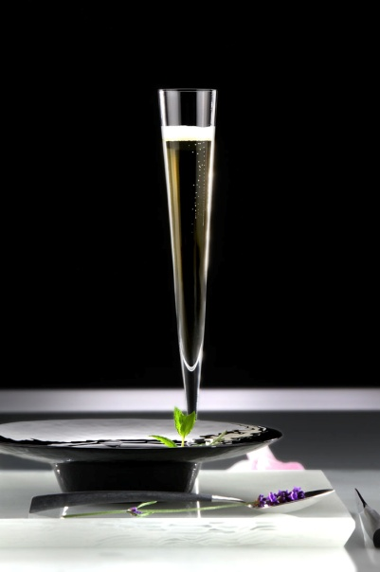
„Vaganza“ by ZIEHER
The filigree champagne flute “Vaganza” is handblown and created in superior handicraft by experienced glassblowers. The result of this work is a crystal glass of highest craftsmanship. With an extra-ordinary height of 33.5 cm, but only 5 cm in diameter, “Vaganza” captivates by its slim silhouette and elegant shape that bestows an exclusive character on the glass. The additionally available versions coated in gold or platinum fascinate with brilliant colours and the luxurios appearance of the applied decors.

“Vaganza” seduces by its charming lightness and adds a
touch of high society to any event.

More information:

WWW.ZIEHER.COM

WWW.ZIEHER-SELECTION.COM

