Risen from the deep-sea

These organically shaped bowls appear like creatures of the sea which float silently
through the depth of the ocean. Even if the tentacles, modeled in numerous process
steps, appear very filigree, they nevertheless form a safe base. Despite the solid stainless steel these hammered bowls award a natural airiness and an almost floating impression.
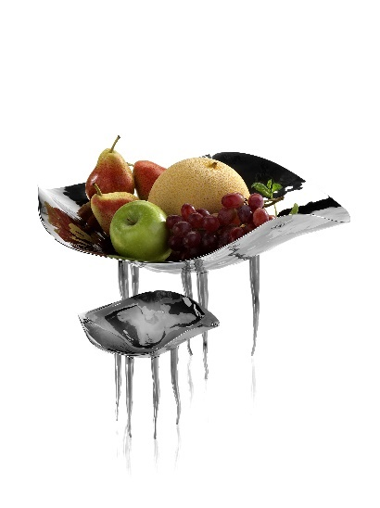
“Medusa” offers the perfect frame for a selection of fresh fruit or extravagantly presented salads and desserts. They are also convincing as a decorative depot area.

More information:

WWW.ZIEHER.COM

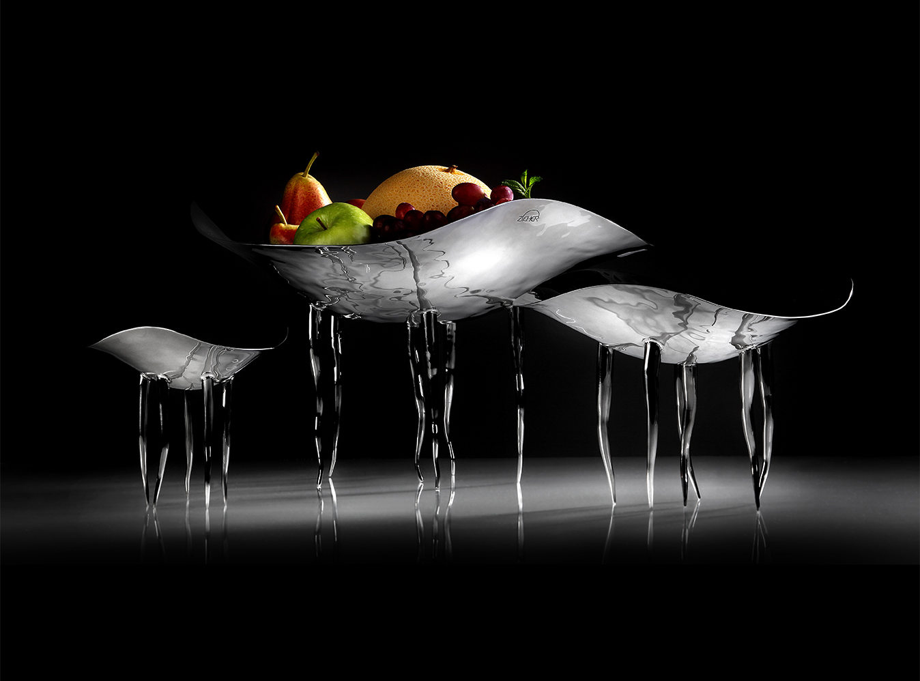
WWW.ZIEHER-SELECTION.COM

