“Donna“ – pillowed on wood!
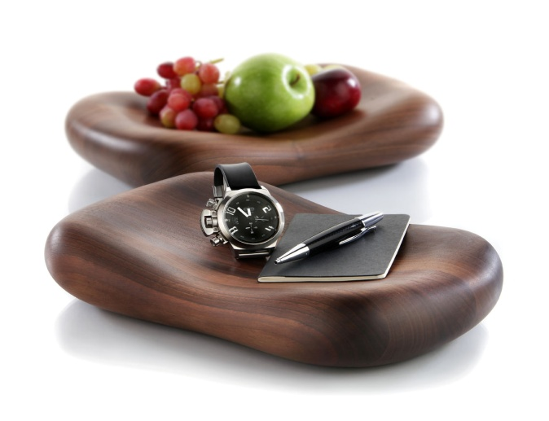
Made of solid wood, milled with dedication and refined with high quality oils! This sculpture of solid walnut wood, one of the finest European types of wood, has its own appearance. The sealing with oils emphasizes the striking grain of the wood and gives the surface a silk-matt gloss as well as fascinating haptics. It is simply a must to touch the softly curved forms of this hand charmer.

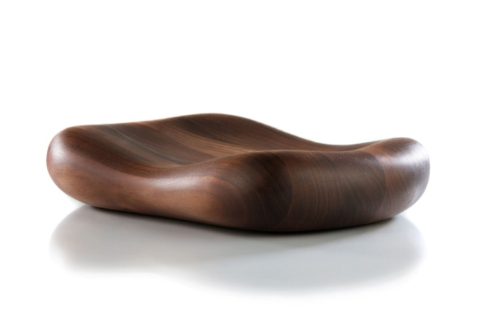
“Donna” is available not only made of wood, but also made of porcelain or satined glass.

Every „Donna“ cushion seduces by the charm typical for the material, be it as a fruit bowl, as a place to keep accessories or as sculptural decoration.

Design: Wilma Greim

More information:

WWW.ZIEHER.COM

WWW.ZIEHER-SELECTION.COM

