“Cave” – pearles of the south sea

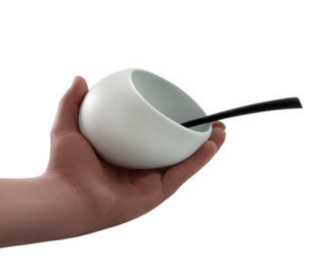
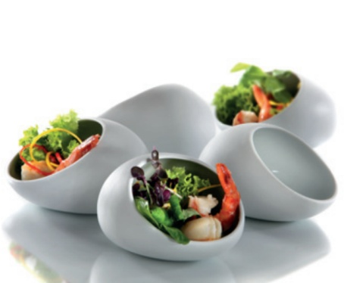
Like the shell hides the pearl, the porcelain miniature “Cave” conceals precious delicacies within its hard shell. This porcelain piece at first sight only partly reveals its interior.

“Cave” consists of intricately worked hard porcelain and captures by its soft shape and the velvety haptics of the unglazed outside. Touching the cave-shaped bowl it feels almost like a palm stone made of white gold, having a soft appearance with delicious contents.

They offer the fitting framework for fruit, nuts and nibbles as well as for tastefully arranged pasta or salad on a solemnly decorated table. The content of the bowls remains protected by the shell of glass, the amply dimensioned opening seduces to snap at a chance. These unique items enthuse as well as a place to keep all kinds of accessories.
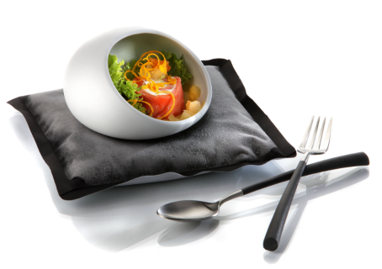

Design: Wilma Greim

More information:

WWW.ZIEHER.COM

WWW.ZIEHER-SELECTION.COM

