THE ART OF DECANTING

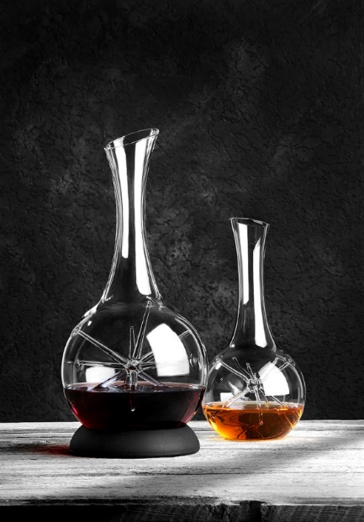
Star
The decanter “Star“ synergizes the aesthetics of a unique copy with the functionality of a professional tool for vinophile pleasure. The individual star raises each carafe to a unique piece. This is pure luxury in our uniform world because not a single star is of the same kind. The filigree rays of the centric star implement the necessary oxygen in a very soft and gentle way and animate the served wine to a very soft enhancement. During the slewing the oxygen is mildly folded in and integrated into the wine. Thus the wine starts to develop on its own terms and not – as with other decanters – just on the surface.

Silvio Nitzsche
WEIN | KULTUR | BAR Dresden
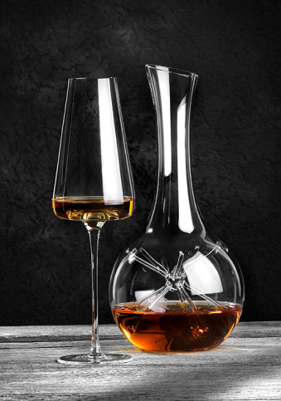
“Star“ - Mini
The small ”Star“ is particularly suitable for the decantation of open wines or small bottles. The ideal charge to provide a maximum of oxygen is 0.375 ltr. The reduced size allows to decant white wines and still to temper them in wine coolers. Also for dessert wines, the staging of innovative high-end cocktails, flavoured spirits to the point of exotic juices this unique product is the perfect solution.

“Star”
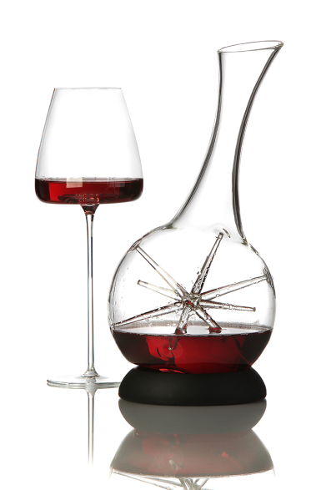
The big ”Star“ has a recessed grip at the bottom which improves the swirl during filling and slewing. On the other hand it guarantees a safe handling and firm stand while serving the wine. An enclosed black silicone collar offers an attractive base and allows inclined positioning of the decanter.

More information:

WWW.ZIEHER.COM

WWW.ZIEHER-SELECTION.COM

