“Shine“ – Elegance and tact in V2A
The stainless steel bowls of the “Shine” series are double-walled. The resultant isolating effect avoids the formation of condensed water when serving chilled dishes - even at higher outside temperatures. Cold food stays cold and warm food stays warm for a longer time. The slanting and slim top edge appears elegant and filigree. The accentuated contrast between the highly polished outside and the ivory-coloured finish on the inside makes that series an eye-catcher.
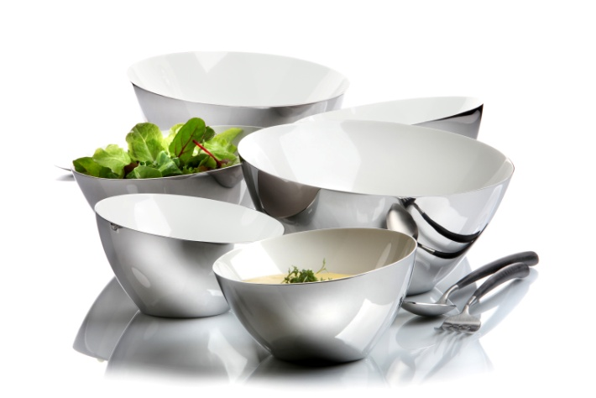
“Shine” is the perfect combination of elegance and unobtrusiveness. It is versatile in application, thus facilitating a variation of presentations and it is effective due to its double-walled construction.
The double-walled bowls of the “Shine” series are available in three sizes and they are delivered in a stylish gift box.

More information:

WWW.ZIEHER.COM

WWW.ZIEHER-SELECTION.COM

06/2016
ZIEHER KG, Kulmbacher Str. 15, 95502 Himmelkron
Marketing: 09273/9273-68; www.zieher.com ; www.zieher-selection.com
Please direct requests for photo or text material to presse@zieher.com

