“Roots“ – Born in sand!
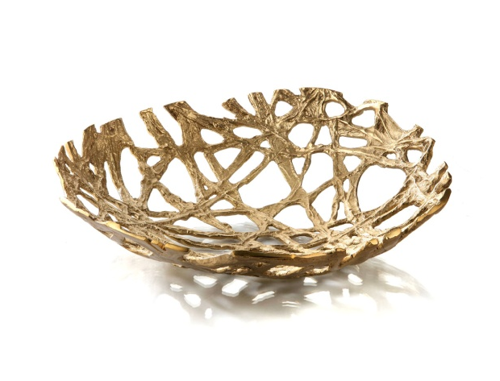
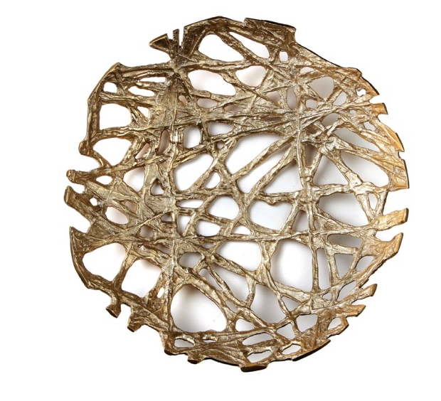
Massive brass serves as the raw material the bowls “Roots” are made of. Unique sculptural items are produced in traditional sand casting and are reminiscent of a tight web of rootlike structures.
Besides the use for the presentation of fruit and bread, these bowls are especially fascinating as sculptures or mere decorative elements.

More information:

WWW.ZIEHER.COM

WWW.ZIEHER-SELECTION.COM

