“Collina“ – Rolling hills of porcelain
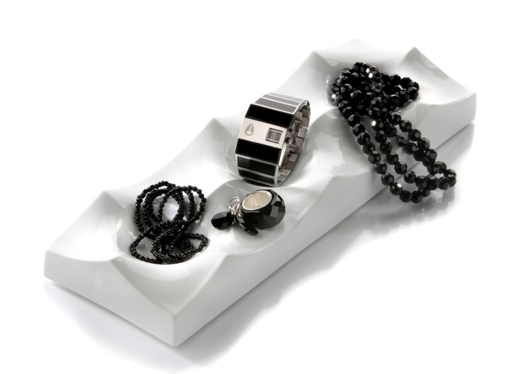
The Italian word “Collina” translates to “hill”, “hill country”. Hills or sand dunes lining up periodically, reminiscent of mountain ridges.

“Collina” is completely made of premium hard porcelain. The strictly geometrical structure permits to array several plates, thus enlarging the arrangement to reach any length and width. Looking at the surface from the side, “Collina” offers a surprising sight and brings to mind a desert landscape arbitrarily formed by the wind.

“Collina”, which is available in two versions, may be used as a fruit bowl, but also as a useful place to keep various items of everyday life, such as keys, mobile phones or jewellery. Even a strictly decorative use may be envisaged. In order to protect sensitive surfaces of furniture, every plate comes with a set of foam rubber feet which can be attached if need be.

More information:

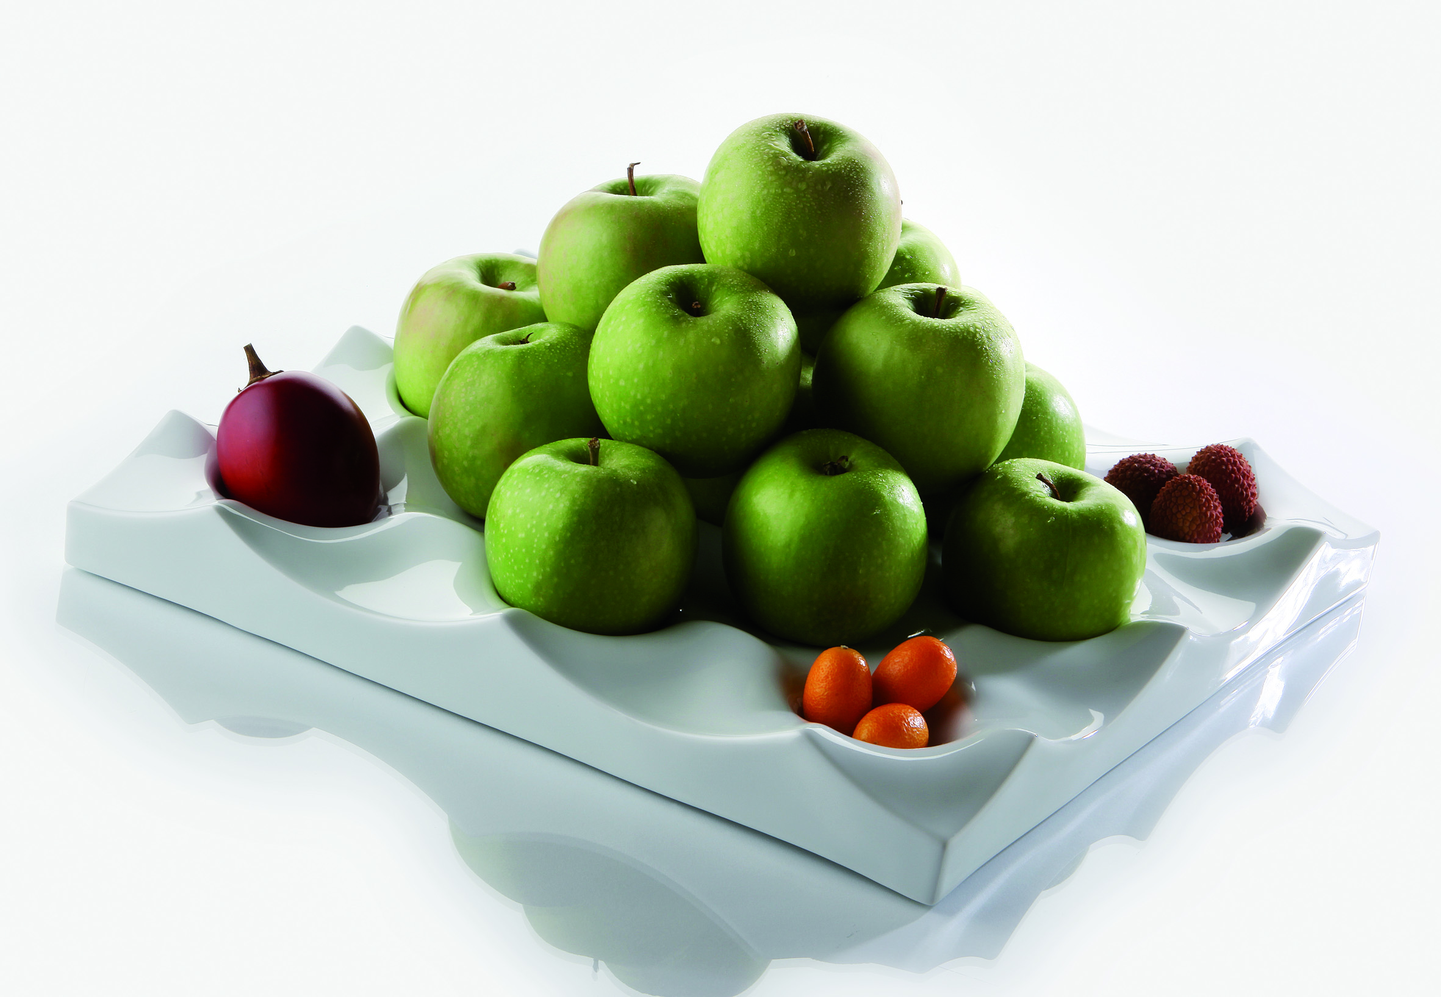
WWW.ZIEHER.COM

WWW.ZIEHER-SELECTION.COM

06/2016
ZIEHER KG, Kulmbacher Str. 15, 95502 Himmelkron
Marketing: 09273/9273-68; www.zieher.com ; www.zieher-selection.com
Please direct requests for photo or text material to presse@zieher.com

