Extravagance for the unique
The cloches made of robust borosilicate glass delight by their imposing size and unusual shape. The light cloches are heat-resistant, dishwasher-safe and very easy to handle.
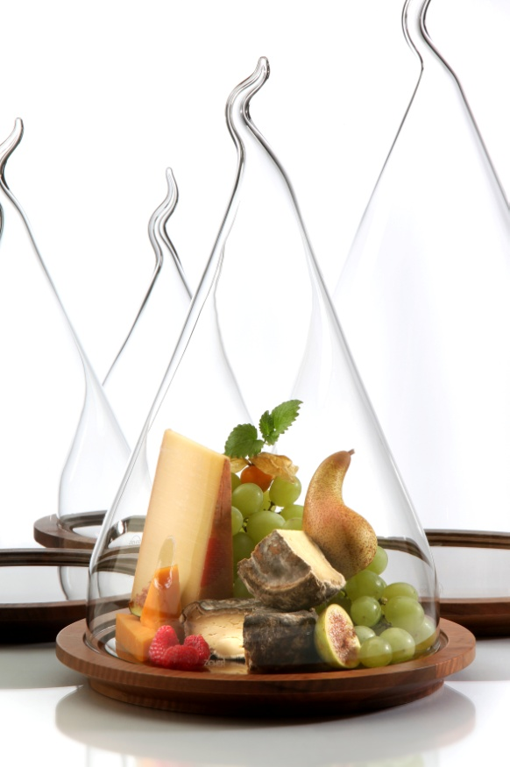
Each item is handblown, manufactured by hand and therefore also shaped slightly different and individual! The fitting plate made of massive walnut, with an insert of clear glass, forms the basis for the precious cover. Whether used for the presentation of an exclusive choice of cheese or fruit or as a place to keep souvenirs, jewellery or collectibles held dear on the sideboard or mantelpiece - the cloches present and protect in an extravagant shape!
The classy cloches are available in sizes of 22 cm and 30 cm in diameter.

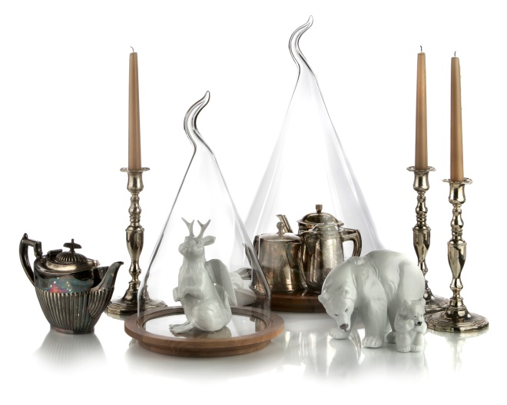
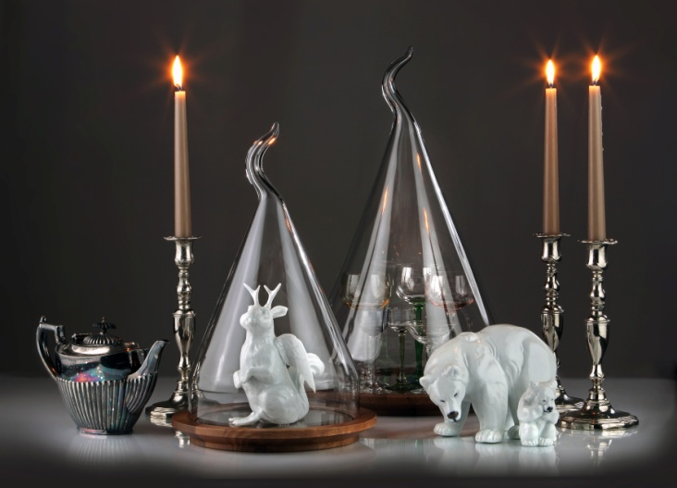

More information:

WWW.ZIEHER.COM

WWW.ZIEHER-SELECTION.COM

06/2016
ZIEHER KG, Kulmbacher Str. 15, 95502 Himmelkron
Marketing: 09273/9273-68; www.zieher.com ; www.zieher-selection.com
Please direct requests for photo or text material to presse@zieher.com

