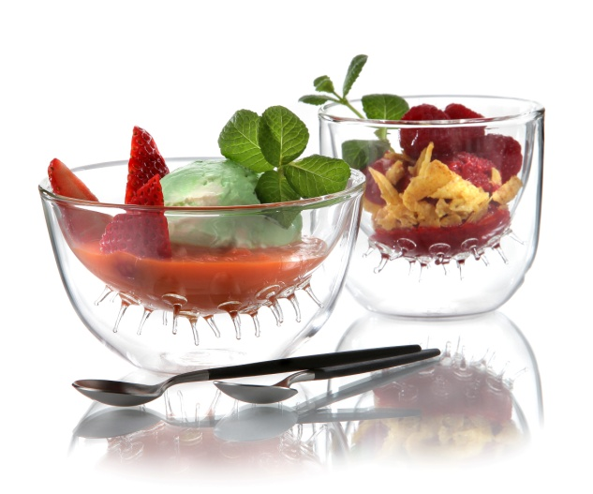
Amusing designs made of glass – “Amuse”
The series “Amuse” puts delicious appetizers perfectly into focus. No matter if hot desserts, fine soups and dips, exotic purees or smoothies – the filigree jars with their organic shape whet the appetite and ensure pleasurable table talks.

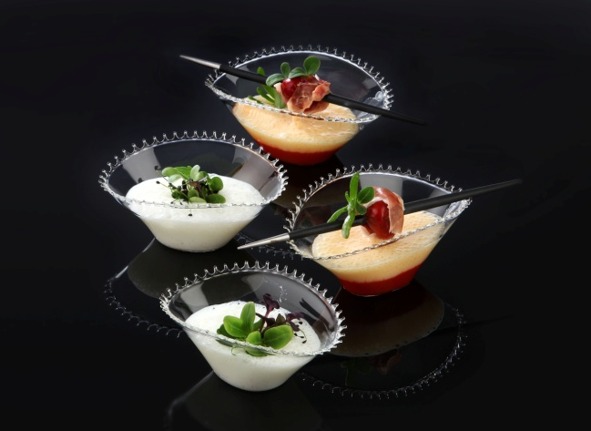
The thin-walled but strong tumblers, bowls and glass tins are made of heat-resistant borosilicate glass and are intricately handcrafted. Due to the vacuum between the two glass walls, the double-walled bowls of the series even retain heat or cold. Glasses made of borosilicate glass (chemical and temperature-resistant) are handblown, which renders each piece of this series unique!

The custom fit gift box provides a stylish framework for these delicate products.

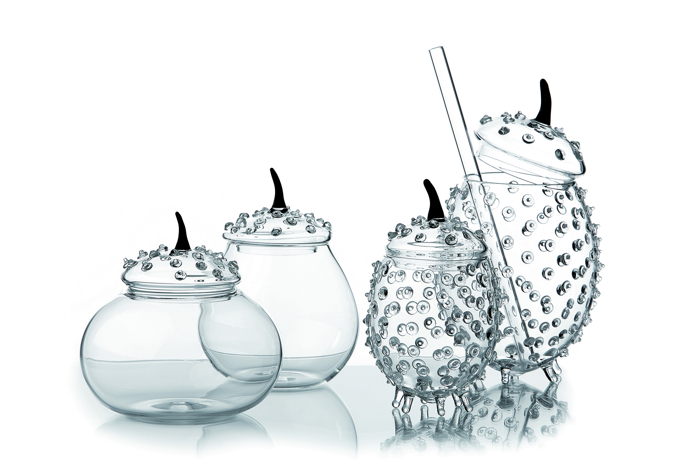
More information:

WWW.ZIEHER.COM

WWW.ZIEHER-SELECTION.COM

06/2016
ZIEHER KG, Kulmbacher Str. 15, 95502 Himmelkron
Marketing: 09273/9273-68; www.zieher.com ; www.zieher-selection.com
Please direct requests for photo or text material to presse@zieher.com

