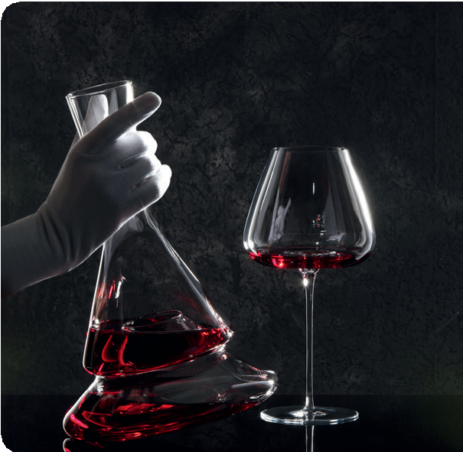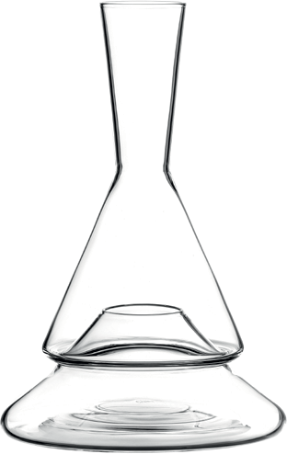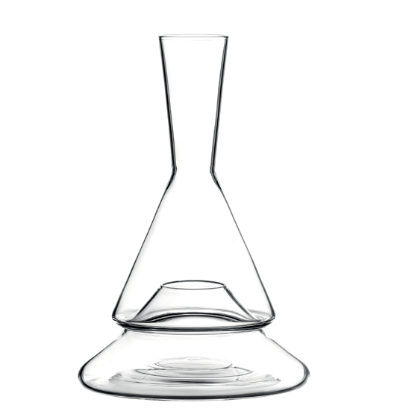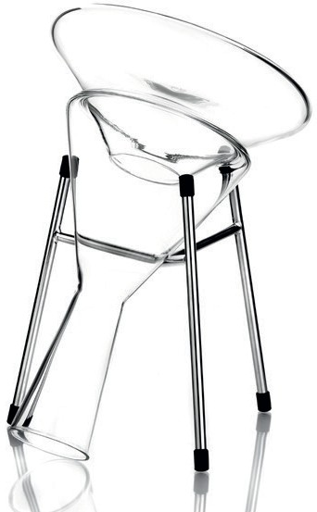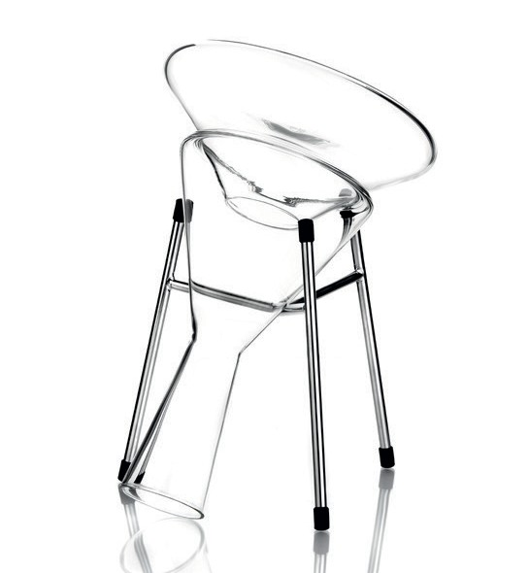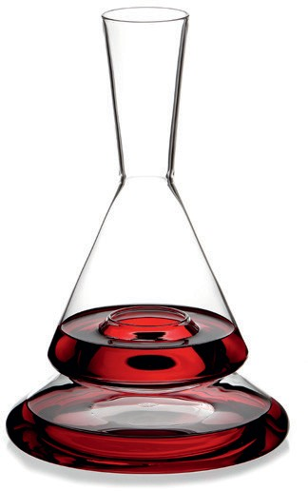F O R W I N E L O V E R S

“Doppio” - how about a little extra?

In the “Doppio” decanter, wine is given a double stage that attracts
attention and provides surprising effects.

The geometric silhouette and the reduced design appears almost technical and directs the view to the inside, because the whole secret of this extraordinary design only discloses in filled condition. Attracti- ve visual effects appear already during the pouring process when the wine is divided onto both levels of the “Doppio” decanter. It almost seems that the wine is levitating.

In addition to the natural flow of the wine, which pours over the inside of the decanter onto the two levels, the division into two levels also has an extremely beneficial effect on the development of the wine.
The splitting creates a significantly larger surface of the wine with
a comparatively small space requirement on the table, which maxi- mises the possible oxygen contact. The division also remains when pouring out, so that the cascaded flow creates a waterfall effect, which additionally increases aeration through swirling.

“Doppio” is elaborately handcrafted from high quality borosilicate glass, which is robust and easy to clean. The ideal charge of the decanter is 0.75 litres in order to generate maximum oxygen contact and the most beautiful optical effects.

Design: Itamar Harari

WWW.ZIEHER.COM WWW.ZIEHER-SELECTION.COM

09/2020
Zieher KG, Kulmbacher Straße 15, D - 95502 Himmelkron • marketing: +49 9273 9273-68 • www.zieher.com www.zieher-selection.com • Please direct requests for photo or text material to presse@zieher.com

