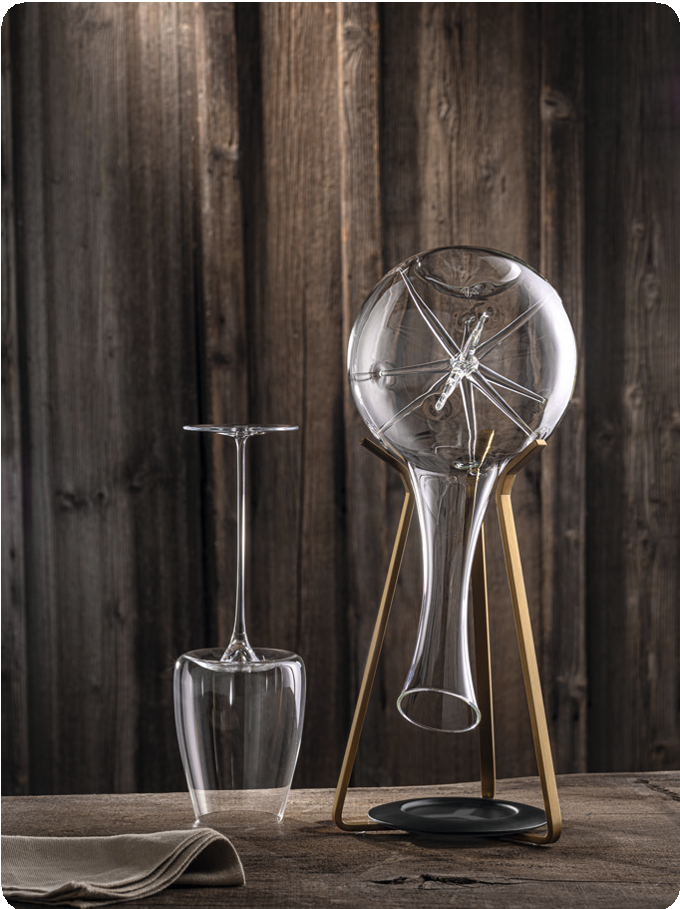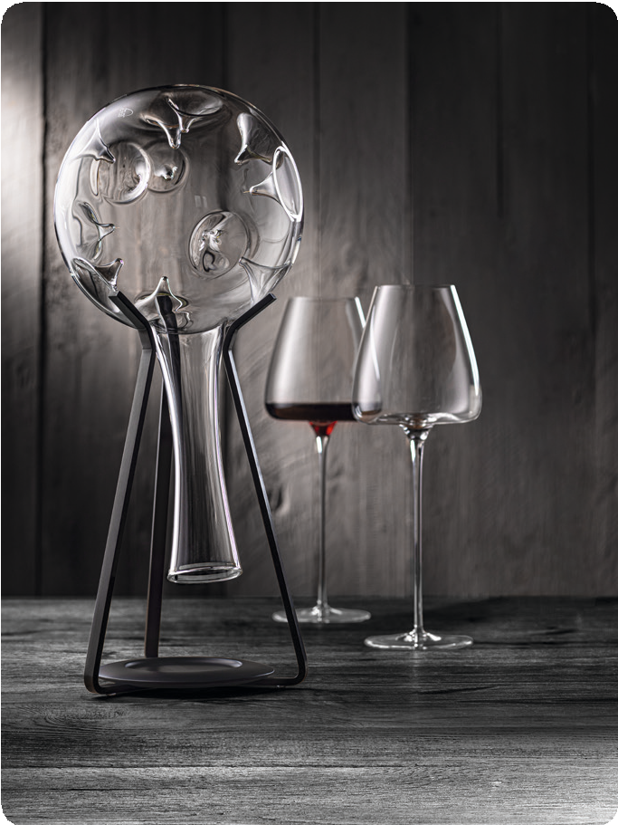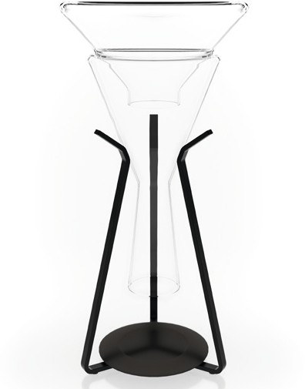F O R W I N E L O V E R S

“DryPod“

Creating a useful tool with a high demand on aesthetics – this was the idea during the development of “DryPod”. The solid rack made of brushed stainless steel, PVD refined in either black or brass colou- red, forms the basis for this shapely product. An accurately fitting drip tray, made of translucent resin, is placed inside the rack and harmo- nises with its anthracite colouration with both variants.

Primarily “DryPod” is a drying rack for decanters. The geometry was chosen in a way that all Zieher decanters can be placed safely, besides the big variations of “Eddy”, “Star”, “Doppio” a.s.o., it can
also take hold of the smaller versions of some types as well as many other decanters in classical format. The drip tray securely collects dripping water and can be easily removed for cleaning.

Even after drying, all decanters are well stored in “DryPod”. No mat- ter if in a showcase or on the shelf, the decanter is stylishly presen- ted by the precious display. Here, the downward-pointing opening helps prevent dirt from getting in easily.

WWW.ZIEHER.COM WWW.ZIEHER-VISION.COM

03/2023
Zieher KG, Kulmbacher Straße 15, D - 95502 Himmelkron • marketing: +49 9273 9273-68 • www.zieher.com www.zieher-selection.com • Please direct requests for photo or text material to presse@zieher.com

